

Cyber Security

CS_TALAKUNCHI NETWORKS BATCH 2



Name :- Ojus P. Jaiswal

**Internship Project 1**

**System Hacking**

**Task 1 :-**Hydra

**Solution :-**

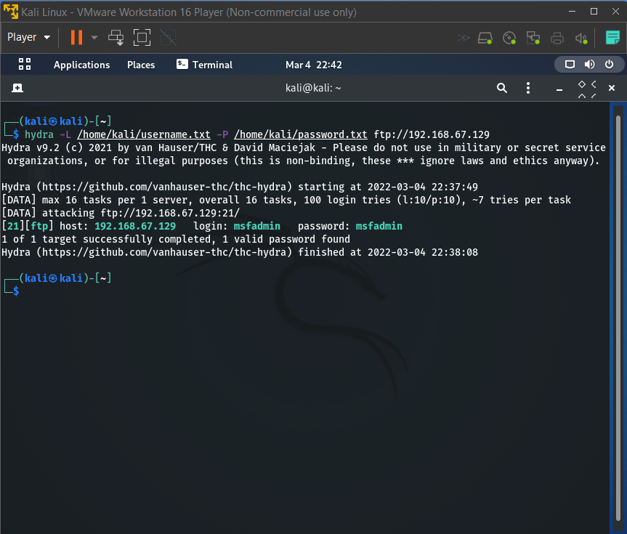

**Task 2 :-** Auxiliary Module

**Solution :-**

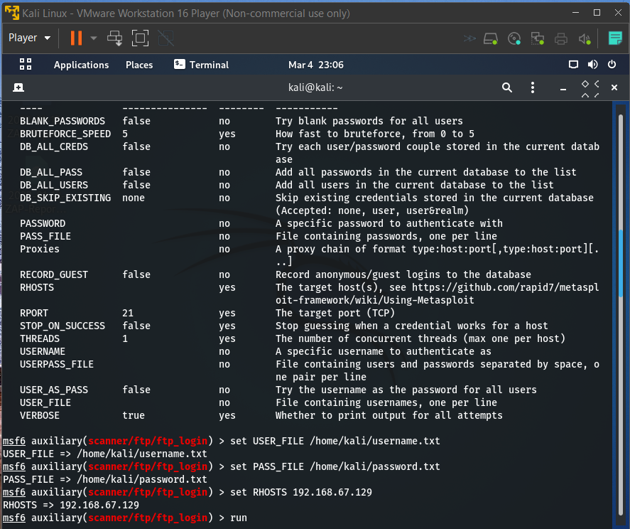

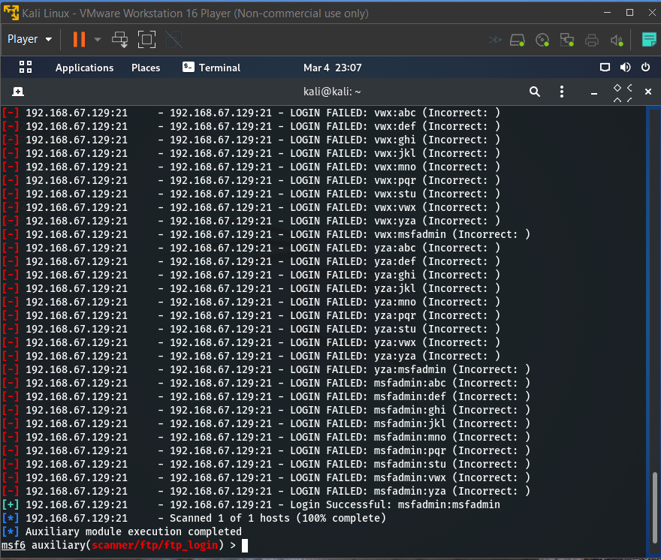

**Task 3 :-**NSE Scripts

**Solution :-**

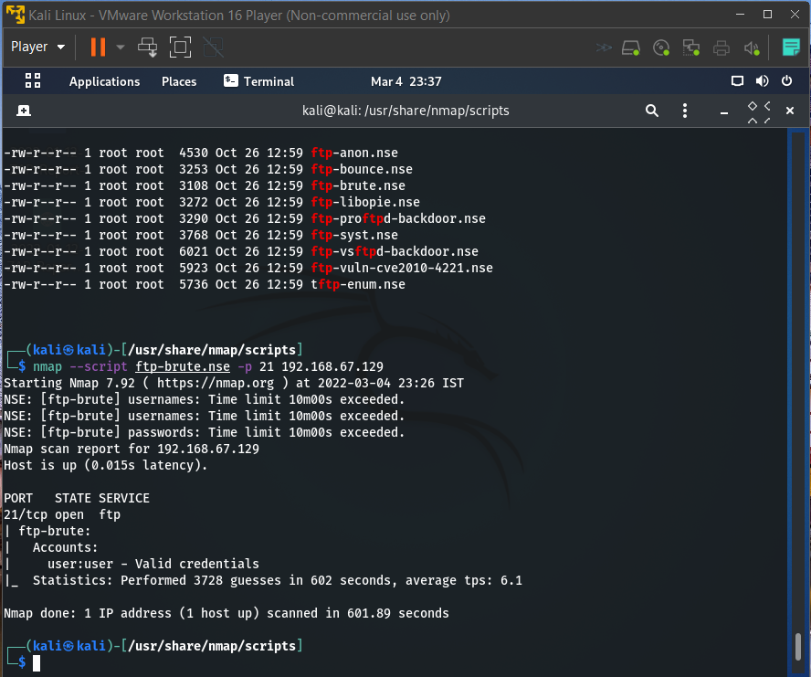

**Task 4 :-**John the ripper

**Solution :-**

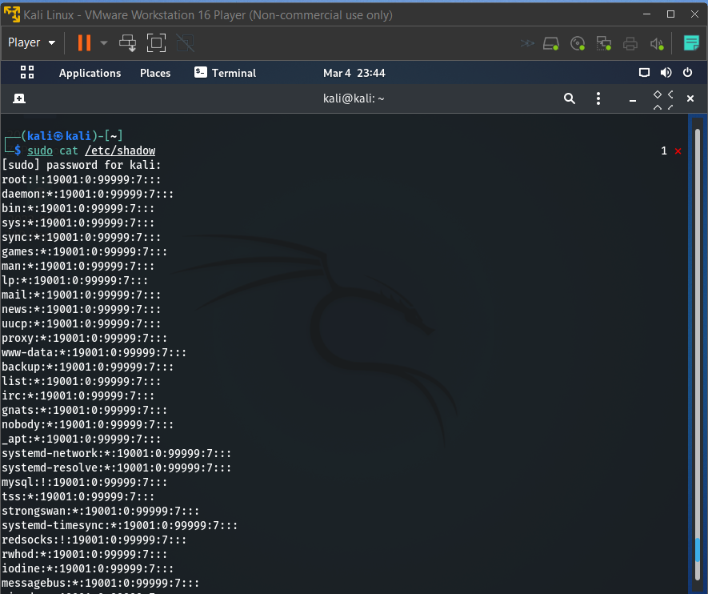

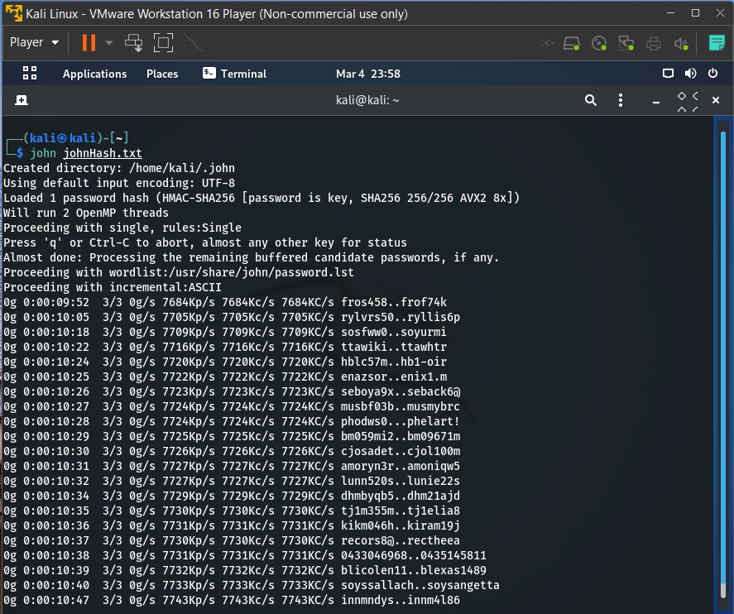

**Task 5 :-**Password generating using Crunch

**Solution :-**

